**Robbin Classroom**

**Friday,**

**Jan. 12th**

   

**Events**

**Reading/Language Arts**

This week in Reading workshop we read, “Backyard picnic” and created a flow chart to summarize the story. We read, “Angelina Ballerina” and wrote about the elements of the story: characters, setting, and plot. We finished our Unit by selecting our favorite book and writing about it.

**Eureka Math- Module 2**We learned about inches, centimeters, and learned how to use a ruler and tape measure. We learned how to collect data and graph the information. We also learned how to subtract 8 from teen numbers by decomposing the teen number into a group of tens and ones. **In Social Studies**, we read a book about Martin Luther King Jr. and watched a video. We wrote a poster about his life. We compared a brown egg and white egg from outside in and found they aren’t really different. ☺

**Reminders**

1/12 End of 2nd quarter

1/16- Martin Luther King Jr. Day

1/19 Report Cards and early release

Library book due on Wednesday

**Homework:**

**– Book It Reading log the “20” minutes for the month of January ☺**

All the children are in need of more Crayola markers and expo markers. We are trying to learn to close the tops tight so they don’t dry up.

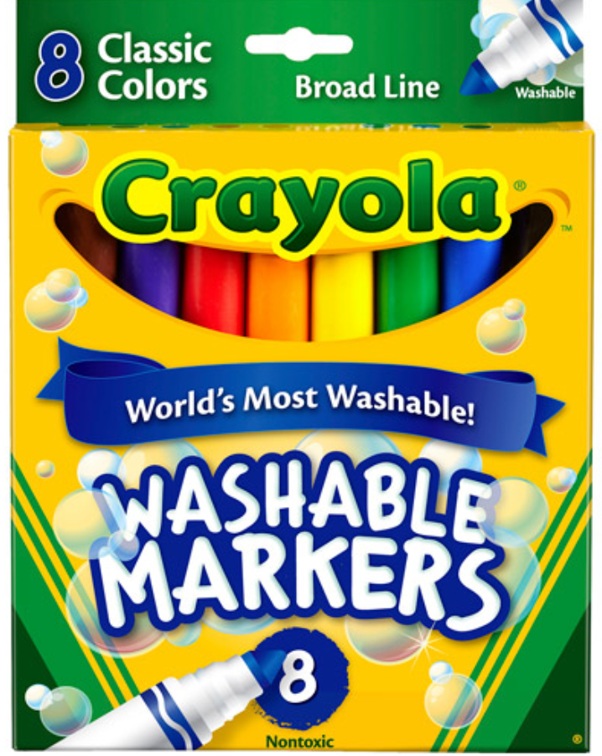

**Valentine Party**

**Feb. 14th**

**2:00-3:00**

**1/ 16 -19th**

**Food Drive**

**Please send in your donation!**



**Character Ed**

Game day next Friday… This week was Winter

Star Student:

Next week Lyra Langhoff

C:\Users\dianerobbin\AppData\Local\Microsoft\Windows\Temporary Internet Files\Content.IE5\BYAWX4UE\MC900438203[1].wmf

**Character ed word of the month:**

**Caring**

Benchmarking for First Grade:

MAP and AimsWeb